***Invitation to Tender for the demolition of the hut at Quarry Moor.***

We are pleased to invite you to tender for the demolition of the hut (Quarry Moor Activities Centre) at Quarry Moor, Ripon.

To ensure the process is fair and transparent for all parties, please follow the instructions carefully. We would like to receive all responses by 9th September 2024.

Any enquiries should be addressed on 01765 604097 or admin@riponcity.gov.uk

Please read the instructions and return the following documents:

* Signed Tender Response detailing your proposed method of demolition;
* Signed Pricing Schedule for the contract;
* Timescale  / timeline of the works to be completed;
* Signed Certificate of canvassing and non- collusive tendering (see appendix 2);
* Detailed organisation information including references for 3 similar works, contact details and insurance provision.

We strongly recommend a site visit by interested parties prior to the submission of a tender, or a detailed telephone conversation. Please contact us via email to arrange a visit.

We hope that you will be able to assist us in this tender and look forward to hearing from you in due course.

Attachments

1. TENDER SPECIFICATION
2. APPENDIX 1 – PHOTOGRAPHS OF THE HUT TO BE REMOVED
3. APPENDIX 2 - DECLARATION OF CAVASSING AND NON-COLLUSIVE TENDERING

# Tender Specification

**Quarry Moor Hut Demolition**

# Background

Ripon City Council is the sole trustee of Alderman TF Spence and manage the land at Quarry Moor in Ripon.

The floor at the hut (Quarry Moor Activities Centre) has been badly damaged and is now unsafe for use. It has been closed to the public since the damage and the decision has been taken to remove the hut entirely. The site is currently unsafe for public use.

Quarry Moor is a SSSI site which means the work undertaken on the site needs permission to be granted from Natural England. The hut is not within the boundary of the SSSI but does border it, so access will need to be made via the car park for the removal of the building. See the maps below for the location of the site and Quarry Moor SSSI boundary (shown in green).

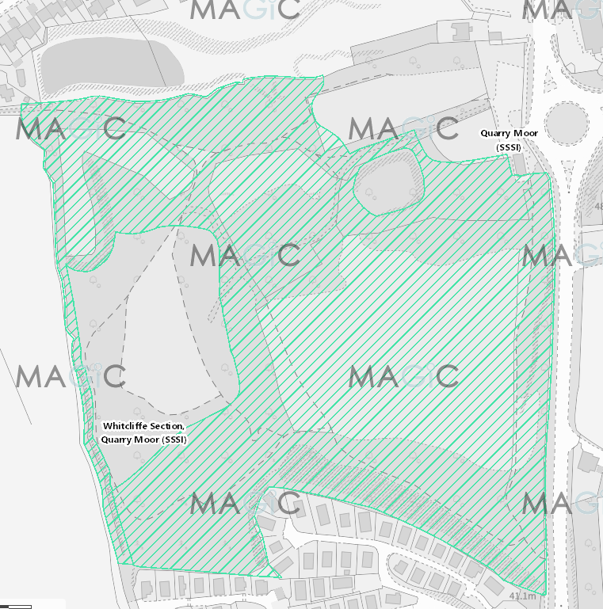

1. **Our requirements**

We expect the tender to include:

* Risk assessment needs to be carried out.
* Supply all fencing to secure the site.
* Supply all materials and tools to remove the timber-built hut from site to leave a flat area.
* Remove the internal fittings, then remove the roof, then bring each wall down into the floor area. Then loading onto skips for removal. Remove the floor and then the brick work and concrete ramps.
* The area is then to be landscaped in fitting with the surrounding area.
* Leave the site clean and tidy and safe. For waste to be discarded of appropriately, including separating netting and metalwork and in line with waste regulations

We are looking for a reputable and qualified company who can provide us with value for money.

# How we would like you to respond to this Tender.

We welcome tender responses from all qualified companies. We would like the process to be as easy as possible and as such, we are not using an application form. When responding to the tender, please submit written plans, which include how you intend to remove the timber hut.

Your response should detail how you will approach each of the areas outlined in our requirements and the associated costs.

We also need information about your organisation, including your contact details, insurance information and references / information of 3 similar works completed for other clients. Please return the following documentation via email to paula.benson@riponcity.gov.uk.

1. Signed Tender Response detailing your proposed removal of the hut;
2. Signed Pricing Schedule/detailed cost template for the contract;
3. Signed Certificate of canvassing and non- collusive tendering (see appendix 2);
4. Detailed organisation information including references for 3 similar works, contact details and insurance provision.

The Council does not bind itself to accept the lowest bid or any quotation.

**4. Working adjacent to a SSSI site.**

Quarry Moor is a SSSI site which means that works undertaken on the site need to have permission this includes using the land to access the hut. You will not be able to have vehicular or machinery access to the site other than through the main gate from the car park as this would require further permission from Natural England.

By responding to this tender, you understand that access is restricted from other sides of the park and that you have considered this within your proposed plan of removal.

# Arithmetic Accuracy of the ITT

It is the responsibility of the supplier to check that all cost areas have been identified and are accurate.

If arithmetic mistakes are found after the contract has been awarded they will not be taken into account. The fees agreed at the time of contract will prevail. The Tenderer shall be deemed to have satisfied itself before submitting its tender as to the accuracy and sufficiency of the rates and prices stated in their tender which shall (except in so far as is otherwise provided in the contract) cover all the contractor’s obligations under the contract and the contractor shall be deemed to have obtained for itself all necessary information as to risks and any other circumstances which might reasonably influence or affect the contractor’s tender. The contractor who submits a tender will be held to have by his/her own independent observations and enquiries fully informed and satisfied himself as to the nature and extent and practicability of the works and as to access to the site and/or storage facility and all points and conditions which can in any way affect the prices upon which this tender is based. The prices for the tender shall include all charges for profits and transport and cartage and labour, materials, plant and insurance and all other expenses. Period of Acceptance of the ITT:

The potential supplier is required to hold their ITT open for acceptance for a period of up to six months from the closing date.

1. **Final Submissions and checklist:**

The Council does not bind itself to accept the lowest or any quote and will not accept responsibility for any expense or loss which may be incurred by any potential tenderer in the preparation of the ITT. Tenderers should treat the tender documents as private and confidential between the tenderer and the Council.

**Appendix 1 – PHOTOGRAPHS OF THE HUT TO BE REMOVED**

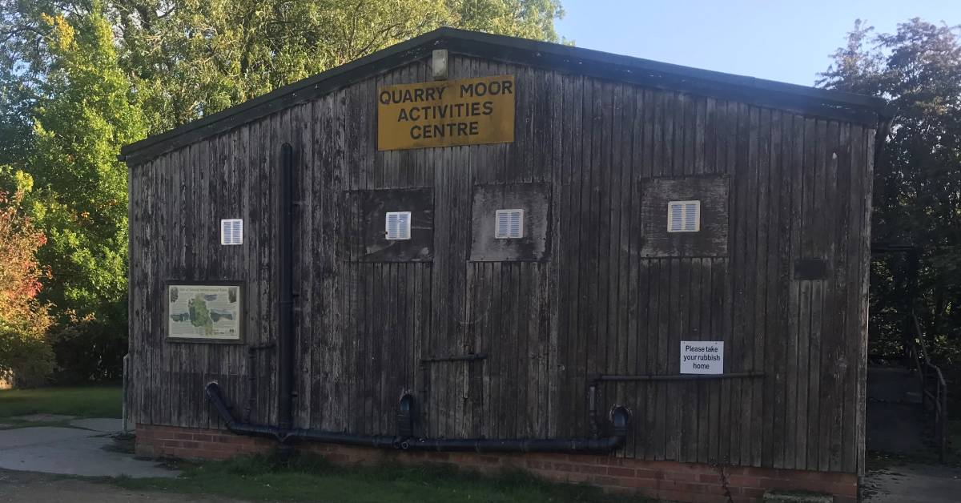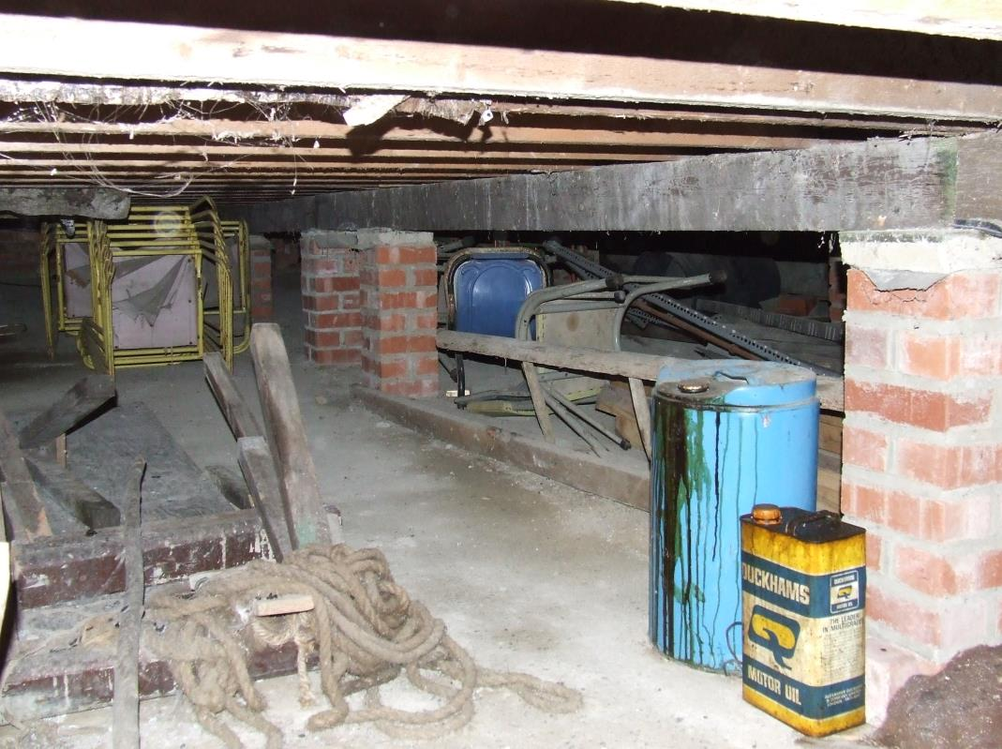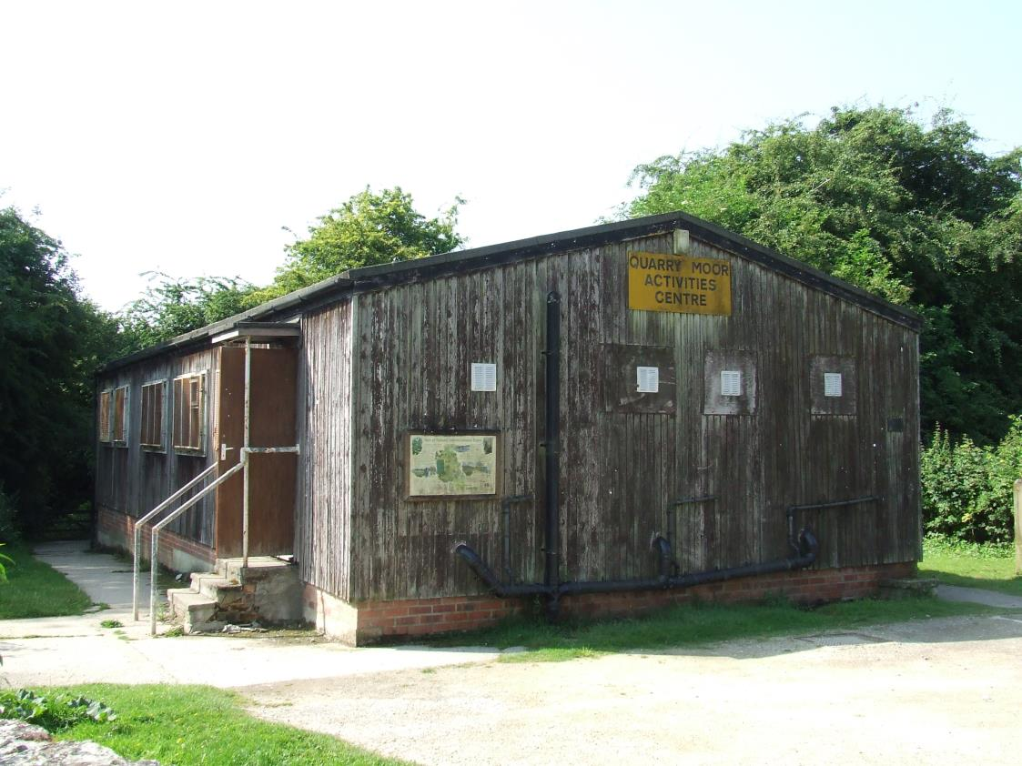

**Appendix 2 - DECLARATION OF CAVASSING AND NON-COLLUSIVE TENDERING**

In recognition of the principle that the essence of selective tendering is that the council shall receive bona fide competitive Tenders from all those tendering.

I/WE CERTIFY THAT:

1. The Tender submitted herewith is a bona fide Tender, intended to be competitive.
2. I/We have not fixed or adjusted the amount of the Tender under or in accordance with any agreement or arrangement with any other person.
3. I/We have not done, and undertake that we will not do at any time before the hour specified for the return of the Tender, any of the following acts:
4. communicating with a person other than the person calling for this Tender the amount or approximate amount of the proposed Tender (except where the disclosure, in confidence, of the approximate amount of the Tender was essential to obtain insurance premium quotations required for the preparation of the Tender);
5. entering into any agreement with any other person that he/she shall refrain from Tendering or as to the amount of any Tender to be submitted; and
6. offering, paying, giving or agreeing to give any sum of money or valuable consideration directly or indirectly to any person for doing, having done, causing or having caused to be done in relation to any other Tender or proposed Tender any act or thing of the sort described above.

Name:

Position:

Date:

In this declaration: 1 ‘person’ indicates any person, body, or association corporate or incorporate. 2 ‘any agreement or arrangements’ includes any transaction of the sort described above, formal or informal and whether legally binding or not.