
COUNCIL OF THE CITY OF RIPON OFFICIAL NOTICE OF A MEETING OF THE ALDERMAN T F SPENCE COMMITTEE

Date: 18th May 2026
Time: 2:00pm
Location: Council Chamber, Town Hall, Ripon.
Council Members: Cllrs Martin-Long, Duncan, Horton, Hardisty, Flatley, and McHardy.
Non-Voting Members: Cllr Cunliffe-Lister, David Taylor, Tanya Bahrouni, Mick Stanley, Simon Warwick, Jeremy Dunford
Honorary Member: Mrs. June Geddes
You are summoned to attend an Alderman Spence Committee meeting for the purposes of determining the agenda items listed below.

Yours sincerely
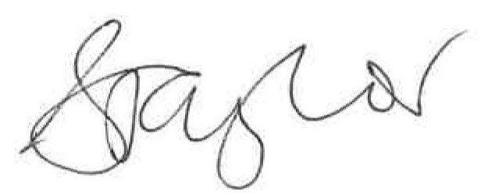
Sally Taylor
Chief Officer
13th May 2026
AGENDA

Housekeeping note:
- Please ensure any mobiles are put on silent
There are no planned fire drills, if the alarm does sound, please make your way downstairs and out of the building to the Market Place
37/26 | - To elect a Chairman of the Committee;  - To elect a Deputy Chairman of the Committee.  - To receive apologies for absence.  - To approve reasons for absence.
38/26 | To request any disclosure of an interest in relation to any matter under consideration at this meeting (financial or otherwise) & to consider any written  requests for dispensation.
39/26 | Members of the public are invited to question, seek clarification or make  representation to members of the Committee on any agenda item as listed below.
40/26 | To receive and approve the minutes of the previous meeting held on 20/4/2026
41/26 | To receive a verbal guide on how to submit Agenda items
42/26 | To receive an update on Financial and Governance Matters:  - To receive financials from 1st April 2026-1st May 2026  - Rural Payments Agency funding update
43/26 | To review the installation of new benches following advice from Ripon Disability Forum & Natural England. Approval to be granted at Full Council on 1st June 2026
44/26 | To receive an update regarding The Hut. Approval to be granted to remove and replace The Hut at Full Council on 1st June 2026
45/26 | To authorise an application for a funding bid as outlaid in the options paper.
46/26 | To approve essential works to be carried out, irradicating Himalayan Balsam/Applying herbicide treatment to invasive species/Cutting & stump treating  Sycamore Saplings. To be taken to Full Council for approval on 1st June.
47/26 | To acknowledge the work carried out by K A Anderson Ltd.
48/26 | To receive an update from North Yorkshire Police
49/26 | To note the date of the next meeting of 21st September 2026

