Date: 13th August 2026
Time: 2:00pm

Location: The Council Chamber, the Town Hall, Ripon, HG4 1DD.

To members of the Alderman T F Spence Committee,
You are summoned to attend an extraordinary meeting of The Alderman T F Spence Committee for the purpose of determining the agenda items listed below:

Cllr J Martin-Long Sally Taylor

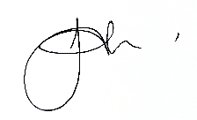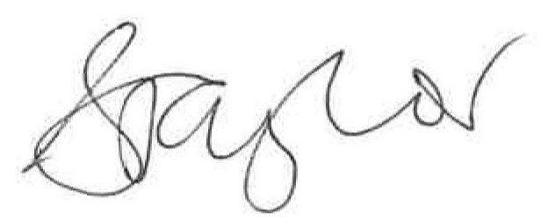
Chair Chief Officer
7th August 2026 7th August 2026

Housekeeping note:
- Please ensure any mobiles are put on silent
- There are no planned fire drills, if the alarm does sound, please make your way downstairs and out of the building to the Market Place

68/26 | - To receive apologies;  - To approve reasons for absence.
69/26 | To request any disclosure of an interest in relation to any matter under consideration at this meeting (financial or otherwise) and to consider any written requests for dispensation.
70/26 | Members of the public are invited to question, seek clarification or make representation to members of the Council on any Agenda item.
71/26 | To approve the sum of £1029.84 (plus VAT) for Northern Powergrid to disconnect the underground electricity supply
72/28 | To authorise additional expenditure of up to £1000 to meet any reasonable & evidenced abortive attendance, delay or remobilisation costs charged by the demolition contractor as a consequence of the postponement

